

⁽SENIOR CITIZENS BUREAU Invitation INTERACTIVE MEETING
Chairman Emeritus 44th Elder welfare programme
Gen. Aban Naiclu, PVSM, AVSM
2642 5555 Senior Citizens Bureau, in association with Cordon Formulations Pvt. Ltd.,
Ph :
Chairman Little mount, Chennei - 15, invites all the members and their spouses, along with
n
an M.D. FRCP.,DSc(Hon.) their friends for an interactive meeting on Saturday, the 15th April 2006, between
Dr.V.S. Nataraj, ,
Ph : 2641 2030 10-30 Hrs and 12-30 Hrs at Kumaran Hospital, 214 (869), EVR Periyar Salai, (Adjoining Sangam Theatre) Kilpauk, Chennal - 10.
Vice Chairman
Mr.N. Subramanian, IRS Dr. V.S. Naterajan,
Ph : 2499 6905 Chairman, 5CB & Geriatric Physician will speak on the topic
Secretary General "Is Master Health Check up Necessary for Senior Citizens? and
Capt.M. Singaraja, C.Eng
Ph : 2823 1388
Joint Secretary Mr. A. K. Narayan,
Er. S. Murugaiyan, B.E President, Tamil Nadu Investors' Association, will speak on the topic:
Ph : 2650 2424
Treasurer "What are the investment options available for Senior Citizens
Mr. S.K. Vasudevan, B.A and what are the tax implications?
Ph : 2473 2943
E.C. Members For details please contact : 2641 _²030, 2626' 2014¹51₁ 2_⁴"²L^{,4}1 13232 Mr.R. Venkatesan, IA & AS
Ph : 2499 7977 Capt. M. Singraja Dr. V.S.Natarajan.
Es. M.D. Vijayarangam, B.E SECRETARY GENERAL CHAIRMAN +
Ph : 2621 6787
Mr.M. Mahadevan, M.A. M.Ed Wind Attention' SUBSCRIPTION
Ph : 2650 0501
Mr.R. Seshadri, B.Sc
Ph : 2626 1332 Annual Members of SCB and LinkAge subscribers from outstations and Institutions
Er.A.N. Manavalarathnam, CE (Retd.) are requested to renew their subscriptions, by April 2006 since the Accounting Year is from
(Civic Affairs) Ph : 2641 1931 April to March. The Revised rates of subscription with effect from April 2006, are as follows. Dr.T.S. Kanalka, MS, MCh (Neuro)
(Health & Medicare) Ph 2233 0935 Annual Life
Mr. A.S. Krubapuri. IAS (Retd.) 1) Subscription for the membership of SCB, including
(Personal Admn.) Ph : 5204 0921 monthly journal 'LinkAge' (Rs) 300/- 2500/- Mrs. Sudha Ramalingam, PUCL
(Legal, Law & Order) Ph : 2539 2459 2) LinkAge Subscription for Outstation
Prof.Dr.V. Balambal, Principal (Retd.) and Institution members only (Rs) 100/_ 1000/-
(Educational, Social & Culture) Ph : 2483 8806 - Our Journal LinkAge is mailed on 8th of every month by ordinary post under bulk Mr.P.S. Santhanakrishnan, SBI (Retd.)
(Finance & Banking) Ph : 2641 1938 posting at concessional rate through Patrika Channel without pre-payment.
Past Presidents - At present address stickers prepared through computer system are used. Hence
Gen. Aban Naidu, PVSM, AVSM request, if any for change of address received till 5th of the month will be incorporated
Ph : 2642 5555 in the same month and the remaining, in the succeeding month.
V. Hariharan, F.I.E. - Remiltance can be made at any branch of UTI Bank in favour of Senior Citizens Bureau,
Ph : 2620 1011
BOARD SB A/c # 006010100811774 at no extra cost, under intimation to this office. LINKAGE ADVISORY
Gen. Aban Naiclu, PVSM, AVSM (Retd.) - To enable correct accounting, kindly quote Membership / Journal Subscriber number
S.P. Ambrose, IAS (Retd.) in all correspondence and M.O. coupon, with full postal address.
Prof. Gomathy Narayanan (Retd.) - In case the Journal is not received by 15th of the month, please lodge a complaint with
.V.S. Natarajan, Geriatrician the delivery post office of your area and the Superintendent of Post Offices concerned, Dr
Capt. M. Singaraia, C.Eng. (Retd.), Editor with a copy to us.
N. Subramanian, IRS (Retd.) - Remittance should be made to Senior Citizens Bureau's official address only, and
QR. Venkatesan, IA & AS (Retd.) not to office bearer's name. +
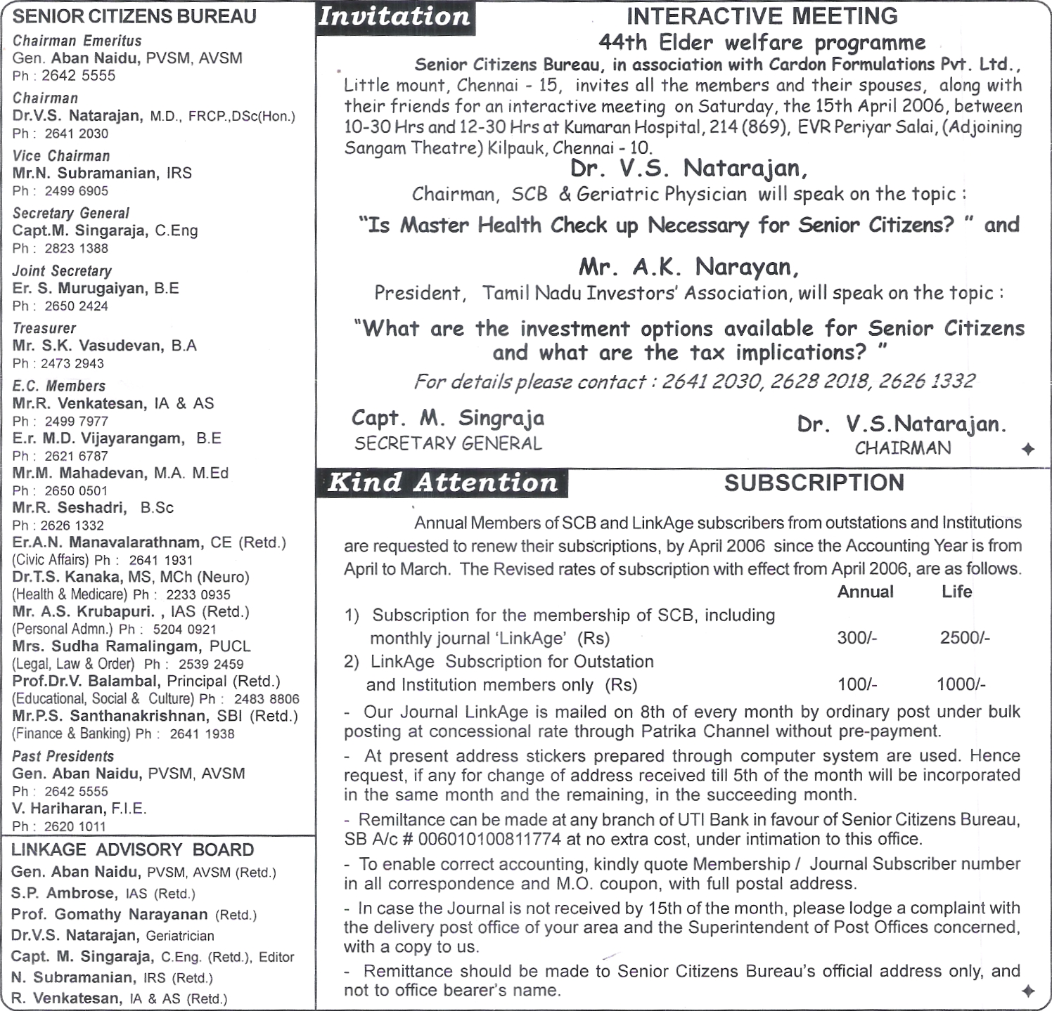
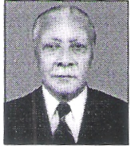
by two minutes. There was an uproar and a Parliamentary Question sent out to me for this lapse. My answer was simple and brief. "The moment the President arrives, at the designated stand, that is 11.00 hrs." Whether he arrives two minutes early or one minute late, that is irrelevant. Of course, this is a privilege, that only the President of India enjoys. Not for us.
BE EARLY-BE ON TIME - BUT NOT LATE, Time lost can't be regained. Time is of great value to us. We must learn to be punctual. Want of Punctuality leads to waste of our time, as well as that of others. Have consideration for others' feeling.
SOMETHING TO PONDER-
If the Cheif Guest arrives late at a function, If trains are not punctual , If aeroplanes are not punctual and If buses are not punctual How do you feel ?
Stick to Time - Be Punctual If you have time to waste, do not waste ours. 4-
evolving plans and programmes. Remember you are an important cog in the wheel of the Senior Citizens Bureau. I am reminded of an incident in my career as General Officer Commanding Delhi, when it was my responsibility to organise the Martyrs Day ceremony at the Raj Ghat on every 30th Jan. The President of India is scheduled to arrive exactly at 11.00 hrs, and that is when the guns will be fired , bugles sounded, and the Members present at Parliament House would stand in two minutes silence, and indeed, this has relevance to all citizens. On that particular day the President arrived supposedly 'in advance and the whole sequence of firing the guns and sounding the bugles was carried out. The ceremony at Raj Ghat was well conducted, but there was confusion at Parliament House, as many Members had not arrived and those present were taken by surprise because of the advance in timing, according to them
being made to improve the getup and contents. It is heartening to note that there is increase in its circulation, domestically and nationally. A good show!
While this is a cause to be proud, I however feel despondent over the lack of punctuality by members. There are many instances when our members turnup rather late at meetings and also at preplanned programmes and health camps. Besides, the attendance is shockingly poor. This does not speak well of the organisation. Committee members and Panel Secretaries must join to contribute to the working of the laudable cause of the Bureau. Every suggestion, big or small, is an important ingredient in
I am glad that several issues of LinkAge have been produced and circulated since its inception during July 2004. Every endeavour is

Franz the Chair 1 'Emeritus | "Something to Ponder" Gen Aban Naidui,

Discussion by Chairman Emeritus
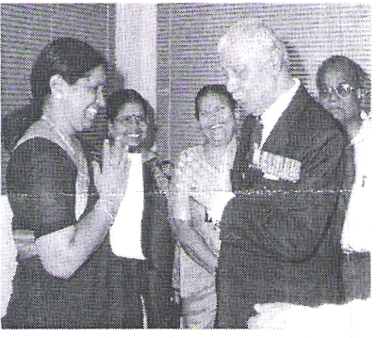
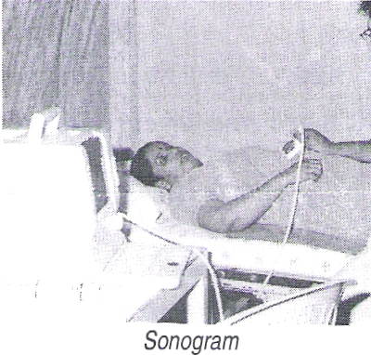
Checkup by Gynaecologist
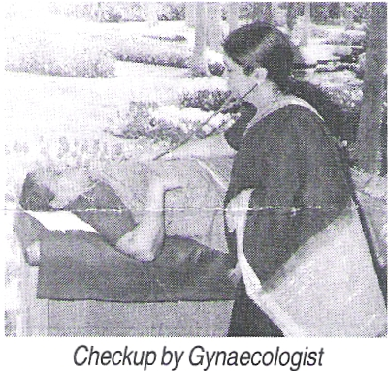
suffer from more of fibroid and bulky uterus problems. In the older age group thickened endo metrium (inner layer of the uterus), cervical polyp and prolapse uterus are commonly observed.
Papsmear findings:
Out of 23 subjects, three (13%) have abnormal papsmear reports which are of simple inflammatory nature, except one case which was advised to have biopsy of the cervix. It is a good news to know that no one who attended the camp had the evidence of pre cancer of the cervix of the uterus.
Conclusion:
In general majority (73.9%) of the older people are not having any major gynaecological problems. They are equally healthy like youngsters.
arrangements. Out of the 23 participants only 3 participants have been identified for further checkup and advice and they have been informed accordingly.
ANALYSIS
Dr. V.S. Natar.-ajan, has analysed the findings and summarised the wellness of the participants
as fcHovvs
23 subjects attended the camp, minimum age was 35 and maximum age was 71. Six (26%) subjects had abnormal findings, three (13%) subjects are below 40 years and three (13%) subjects are above 40 years. It has been observed by pelvis screening that the younger age group
Senior Citizens Bureau organised a medical camp on "Healthy Women" on 18th March 2006, at Kumaran Hospital., Chennal - 10. A total of 23 participants availed of this facility consisting of BMI Test by correlating height & weight, BP Checkup, Blood Sugar (Random) test. U/S Scan of pelvic region and thorough clinical examination by Gynaecologist for symptoms of any disorder / disease Gen. Aban Naidu, PVSM, AVSM Chairman Emeritus, associated himself with this camp and offered his well wishes to the participants. Volunteer members, Capt.M. Singaraja, S. Murugaiyan, S.K. Vasudevan, M. Mahadevan, R. Seshadri, M. Subbian, S.K.D. Murthy, and R. Madhavan looked after the
Activities " CAMP ON HEALTHY WOMEN" 43RD ELDER WELFARE PROGRAMME
V
GApril2006 ^{e}.- LinkAge monthly journal of Senior Citizens Bureau

Dr. V.S. Natarajan , IVI.D, FRCP, DSc (Hon), Geriatric Physician
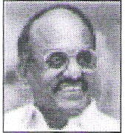
Q : Is euthanasia practised in our country?
Ans : One important human right aspect of old age is euthanasia. Old age is a stage when one is closer to death than in any other age. When one sees an aged person who is sufering from some terminal disease, one asks the question, "Is it necessary to prolong the life of this person?" Euthanasia has its origin from Greek words Eu (mean Well') and thanatos (meaning 'death') and it literally means an easy death. The 'declaration of Venice' at the, meeting of the World Medical Association in October 1983 has laid down that "a physician may relieve suffering of a terminally ill patient by withholding the treatment with the consent of the patient or his immediate family member in case the patient is unable to express his will and 'The physician may refrain from employing any extraordinary means which would prove of no benefit for the patient".
Assisted suicide, an action taken by a patient intended to cause his own death with drugs supplied by a physician, is illegal In most of the countries. Physicians can provide treatment Intended to minimize physical and emotional suffering, even if a secondary result Is the shortening of life, but they cannot specifically intend to hasten death.
The Indian Constitution (Article 21) asures that 'no person shall be deprived of his life by the State except according to the procedure established by law'. The right to life protected by the Indian Constitution has not been Judicially held to include 'Right to die'. The question arises whether a person who has no hope of recovery should be forced to live ? Should he not be allowed to die peacefully without suffering from further physical and mental agony?
In India, euthanasia is not legalized. Because of increasing life span there are more number of elders than ever before. Many elders suffer from incurable diseases without any social support. How are we going to treat them? Who is going to look after them when they are terminally ill? What about the destitute elders ? Now, time has come to think about euthanasia. The law should be carefully framed; otherwise it can be easily misused.
Q&A
the use of harmful laxative and mineral oils. Dietary fibers can absorb and hold water and thus are valuable bulky agents as they increase transit in the gut. The elderly should include in their diet 40 gms. of dietary fiber per day. Dietary fiber not only prevents constipation but also reduces (i) the risk of cancer colon, (ii) blood sugar (iii) cholesterol and (iv) incidence of gall stones.
High fluid intake is essentiai along with the fiber food. Fiber may interfere with absorption and digestion of fat, protein, calcium and trace elements. The benefits of including fibres in the diet are likely to overweigh any drawbacks. There is a good deal of fibrous matter in millets, wheat, ragi, horsegram and rice bran, To get relief from constipation, the patient should mix two to four spoonfuls of fiber supplement in milk or water and drink. There is plenty of roughage in greens, plantain stem, cabbage, cauliflower, drumstick, bittergourd, date, mangoes, figs, guava and wood apple. It is commonly believed that bananas are good for constipated patients but the quantity of roughage in bananas is insignificant. Only the starch in bananas loosens and softens the stools. There is plenty of fibrous matter in pepper, coriander, dried chillies, omum, fenugreek and sundaikal (dry), Milk, sugar, fat, eggs, meat and fishes are devoid of soluble fiber. The content of dietary fiber in the commonly consumed food items are given in the table.
DIETARY FIBER CONTENT OF
COMMON FOODS
(100 gms) FIBER (g)
Ragi (Madua) - 3.6 Asfoefida - 3.2
Rice bran - 4.3 Drumstick - 4.8 Bengal gram (whole) - 3.9 Sundaikai (dry) - 17.6 Green gram (whole) - 4.1 Coconut (fresh) - 3.6
Horsegram (whole) - 5.3 Cardamon -20.1
Peas (dry) - 4.5 Chillies (dry) - 30.2
Soyabean - 3.7 Chillies (green) 6.8
Kuppakeerai - 6.1 Cloves 9.5
Cluster Beans - 3.2 Corriander 32.6
Double beans - 4.3 Fenugreek seeds - 7.2
Pepper (dry) 14.9 Ornum -21.2
Tamarind pulp 5.6 Gooseberry 3.4
Groundnut (Roasted)- 3.1 Dates (Dried) 3.9
Conclusion : It will be a good morning if the elderly persons get regular bowel movement without any laxatives. it is no wonder the day will be a pleasant one for him !
CONSTIPATION
at least fifty percent of them take laxative quite unnecessarily.
Causes : Lack of adequate fibrous matter in the food consumed. Intestinal cancer or obstructions, hernia, piles and fissure in the anus, inadequate secretion of thyroid glands, excess calcium in the body (hypercalcaemia), lack of potassium (hypokkalemia) and mental depression.
Elderly persons avoid drinking adequate quantities of water. Drugs like iron tonics, painkillers, antacids, diuretics, antidepressants, anti hype rten sive agents and sleeping tablets.
Lack of adequate exercise
Old people avoid visiting the toilet frequently because of insanitary conditions in the lavatory.
MANAGEMENT:
Treatement of primary causes
If a specific cause is identified, it should be corrected e.g. treating hypothyroidism, management of depression, correction of dehydration etc.; if any drugs are responsible, it must be stopped or dosage may be reduced.
High fluid intake: A high fluid intake must be maintained. An older person should consume a minimum of 2 to 2.5 litres of fluid per day.
Regular exercise
Physical activity should be encouraged. Daily exercises like walking is very essential to avoid constipation. Those who are bed-ridden must do their exercises in the bed itself. Use of abdominal massage has been shown to prevent constipation. Pelvic floor exercises along with abdominal exercises are good in preventing constipation.
Intake of dietary fiber
The fiber content in the diet plays an important role in prevention of constipation. Dietary fiber is the name given collectively to indigestible carbohydrates present in foods. Many older persons select diets that lack fiber content. This choice together with an inadequate fluid intake can lead to persistent constipation and often to
Constipation is the most troublesome of disorders affecting old people. Senior citizens are always
obsessed with the movements of bowels and

I From the Chairman
\1
April 2006 -.*- LinkAge
A monthly journal of Senior Citizens Bureau G

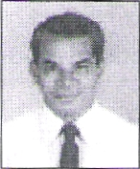
BEST WISHES FOR BAISAKI / BIHU IGUDIPUDUVA / UGADI / VISHU
help you regain perspecitive.
Cry. There's nothing wrong with crying. In fact, it often makes a person feel better. Sob your heart out when you are alone.1f you're feeling stressed or angry a lot of the time, crying can help you relax.
Wait. Just as you can get into a bad mood for what seems like no reason, that mood will also pass. If your negative mood sticks on too long, if it's interfering with the way you deal with friends, parents, school, or other activities, then you may want to talk to a college counsellor, parent, or therapist about what you can do to feel better. +
AGONY AND ECSTASY
(Courtesy: NIE)
Agony and estasy are the two extremely opposite qualitities of human nature. Agony is a resultant character of human feelings filled with frustration, sorrow and suffering. Agony in the negative sense is an undesirable phenomenon of human mind that lets down one's happiness and becomes responsible to create a psychological barrier detriment to the progress and social well being of an individual. It is an unhealthy sign for both the individual and the society's health.
The overall pattern of one's lifestyle is more or less totally distorted and defaced following the state of agony one undergoes. While such are the adversities unleashed by a state of agony, ecstasy on the other hand is a welcome tendency among people who are psychologically let up by the waves of happiness and joy. Agony and ecstasy are, in fact, complementary to each other. While agony is indicated by a mood of dejection, sorrow and a psychological set-back, ecstasy is denoted by a wave of exaltation and happiness.
On an overall analysis of the aspects of agony and ecstasy, it is learnt that these two contradictory and complementary trends among individuals are much essential for a well balanced and normal life. In other words, we need to strike a balance for these two human qualities. +
Care & Share
MOOD SWINGS (Courtesy: NIE)
Do you ever find yourself getting really irritable for practically no reason.? Or suddenly feeling down in the dumps without knowing why? Swinging from sadness to anger to joy In a matter of minutes can make many teenagers feel as though they're on an emotional roller-coaster ride. But why is this so common in the teens?
Dealing with constant change and pressure is part of the answer. May be the semester exams are looming large in front of you. May be you're starting a new activity and not able to see old friends so much. It might feel as though there just isn't enough time to do everything.
Being a teen means struggling with issues of identity and self-image. Being accepted by friends feels extremely important. Teens also may notice, for the first time, a sense of distance from parents and family. Being independent is fun, but it can be lonely too at times, creating mood shifts.
Understanding that almost everyone goes through mood swings during their teenage and knowin^{g} that there are plenty of solutions out there can help. Here are a few that may appeal:
Recognise you're not alone. Talking to your friends who go through the same mood swings will help you realise you are not alone.
Catch your breath. Or count to 10. Be fully aware of your feelings so that you are not ruled by them.
Exercise, Regular exercise produces more beta-endorphin, a hormone that controls stress and improves your mood. Go for a run, play some badminton, ride your cycle around your home, or punch a punching bag.
Get enough sleep. Though it can be hard to find enough time, getting adequate rest is very important. Being tired can lead to more sadness and irritability.
Be creative. Get involved 'in some sort of project, like starting a journal or diary, building something with your own hands, or working on an art or music piece. Writing can help you organise and express your thoughts and feelings and will make things more manageable.
Pray. Knowing that the power behind the universe cares about you can
it. If we tend to develop the full potential of our youth, particularly rural youth, the un employment and frustration of the youth can be solved to a great extent by self employment and entrepreunership.
The acknowledged thinkers like APJ Abdul Kalam, MS Swamianthan and Amartya Sen therefore advocated many ways and means in agriculture, industry, business and service sectors through extensive use of IT We come across students from rural areas also who excel in their studies, lab oriented product developments and IT related solutions. They need much more extensive support from Govt, NGOs, Corporates and VOs for training, development and capital assistance. I am seeing potentioal opportunities highlighted by New Indian Express in their regular columns like "Money Spinners" by Ken Gold (Free website<http://seeklu,.k.com>l and Virtual Career (E Mail - <career@epmltd.com>). Many are earning high income by providing easy solution in the internet after identifying the common needs and wants.
It is very interesting to learn that the I I M-A graduate, a former street vendor of Idlis with his mother has decided to venture into chain of Idli shop business all over India. The recent trend of entrepreunership of the youth is really a welcome feature.
More and more particpation and involvement of women 'in many spheres is promising. For example there was a State level convention of Women Panchayat Presidents in March 17, 2006, at Chennai, focussing on several vital issues. Bihar has passed a bill to provide 50% reservation to women (MBC-20%, SC-16%, ST-1 %) in all the posts of 3 tier Panchyati Raj Institutions (PRIs), on 03-04-06. Self Help Groups have to align themselves in all aspects of Governance and Development, without letting in the evils like corruption and politics.
Let the duty - bound Senior Citizens motivate the youth and women to take up Self-Employment and encourage the parents to let them fly high with "Wings of fire". India will certainly flourish. +
The Citizens of India are proud and joyous of the achievements of our men and women in the recently concluded Common wealth Olympics. It does create a confidence that we can do
917*T#P7N2N=-
BETWEEN YOU AND ME
0 April 2006 -.*- LinkAge A monthly journal of Senior Citizens Bureau

members and Panel Secretaries of the SCB. As a first step, it was decided to extend a helping hand to school students. Th _{I} ru. M. Mahadevan, EC member has offered to work 'in association with Thiru. P. S. Santhanakrishnan and come out with suitable project proposals for approval by EC.
- SCB has identified a girl student cartoonist and a blind professor running a foundation for the Blind. The EC approved to avail of a suitable occasion to invite and honour them.
- The EC authorised the Secy. General / Editor of LinkAge, to effect 'imporvments as deemed necessary /feasible, to commensurate with the cost.
- A reference was made to the prolonged illness of the spouse of former Treasurer Thiru. S. Radhakrishnan . The EC offered its special prayers for her speedy recovery.
- EC decided to nominate substitutes where the current EC members are unable to spare time for the activities of the SCB.
- Sec. General. appealed to the members to deliberate on the specified item of the agenda and to reserve other subjects under any other item of the Agenda so as to avoid deviation.
- The Treasurer presented Receipt and Expendtiture statement for the month of February 2006 and it was adopted by the EC.
- Gen. Aban Naidu, PVSM, AVSM, Chairman Emeritus in his concluding remarks appealed to all the EC members to contribute their mite and share responsibilities to reduce the burden of Secy. General and Editor LinkAge.
- Thiru. M. Mahadevan proposed a vote of thanks and the meeting was concluded. +
U-117⁻6VO,55(.0Lb 6TLD.01
d7‘6067DI7⁻ q,6,6j1T60b1S
,5 675 621 ^{ff} LP110,0I6i65 6iT
Secy. read out the minutes of the last EC meeting held on 01-02-2006 and were adopted by the E.C.
- The Secretary General, Capt.
M. Singaraja then briefed the E.C. on the points arising out of the last E.C. meeting. After a detailed discussion, the following decisions / clarifications were made--
Even though World Elders Day 2005 was celebrated on 01-10-2005 contribution of Rs. 25000/- less TDS, from IOB Chennai was received only now due to certain formalities / procedures adopted by the IOB in such cases.
- EC approved payment of Auditor's fees. The Treasurer was requested to render accounts of SCB for 2005 - 06, in time.
- The Sec. General informed that so far, no decision has been arrived at the revised constiitution of the All India body in the meeting held at Bangalore on Jan 29 and 30, 2006. The next meeting as proposed by Mr. Dhammi will be at Chandigarh. (Please refer to The Minutes of Feb.'06 EC meeting.)
- It was informed that the TamilNadu Senior Citizens Association is a State level federation of Senior Citizen organisations. SCB is already an affiliate of this federaiton.
- EC decided to issue a formal appeal to all existing life members to offer a special contribution of their choice, not less than Rs. 200/- to match the hike of Life Membership fee from Rs. 2000/- to Rs. 2500/-
- The Secretary General informed that the corpus fund of the SCB has reached Rs. 3.50 lakhs as FD in 10B. He traced the history of the corpus fund and thanked all starting from Gen. Aban Naidu,PVSM, AVSM, Thiru. N. Subramanian, Thiru. V. Hariharan, Dr. V.S. Natarajan, Capt. M. Singaraja and others. He also explained in detail how the various activities of the SCB have contributed to its finance.
- In the larger interests of the society, it was decided to make a serious attempt to implement certain projects utilising the service, and expertise of
- The Executive committee meeting of SCB for the month of March 2006 was held at 11-00 Hrs on 01-03-2006 in the Adm. Office. The Chairman Dr. V.S. Natarajan called the meeting to order. Nine members attended the meeting and two members informed of their inability to attend the list is as follows -,
Attended: Gen. Aban Naldu, PVSM, AVSM, Dr. V.S.Natarajan, Eng, Capt. M. Singaraja, Eng. S. Murugaiyan, S.K. Vasudevan, P.S. Santhanakrishanan, M. Mahadevan, S. Sheshadri and Dr. V. Balambal.
Regretted : Eng. M.D. Vijayarangam & Dr. T.S. Kanaka.
- In his opening remarks, Gen. Aban Naidu, AVSM, PVSM, Chairman Emeritus, expressed his strong resentment over the continued absence of Panel Secretaries in the E.C. meetings. He suggested ways and means to overcome this problem.
- The Chairman Dr. V.S. Natarajan in his address reviewed the activities of the Bureau and appreicated the activities of "Anandarn", an old age orphonage atAmbattur during his visit on 23-02-06 and encouraged them by arranging free visits by Physiotherapists periodically. He expressed his happiness about good response to Flu Vaccination camp at his clinic on 24-02-06. (Please see Mar'06 issue of LinkAge under "Musings", for coverage.
Dr. V.S. Natarajan also informed that next Medical Camp on "Healthy Women" will be held on 18-03-2006 at Kumaran Hospital. All the members were requested to avail of the facility.
- Dr. V. Balambal, EC member , informed that the Probus Club, Chennal is honouring Tmt. Kausalya Sarathy, LM -19 of SCB, on 09-03-2006 in recognition of her services in the field of Geriatric Nursing during the celebration of World Women's Day. EC appreciated the gesture.
- Thiru S. Murugalyan, Joint
EC Meeting CONFIRMED MINUTES OF EC MEETING HELD ON 01-03-2006
A monthly journal of Senior Citizens Bureau

• April 2006 -*.- LinkAge

1)
HEALTHY CUSTARD
M. Satti Raju
Custard apple or Seethaphal is a small and hardy tree, of the family `Ammomacae'. This plant is mostly raised from seeds.
Seed - raised trees take about three to four years to bear fruits. In farmhouses and large gardens, self sown seethaphal trees can be found. It perfers a warm and dry climate and dislikes water clogging. The fruits are produced from June to November. Sandy and rich loamy soils are mostly suitable for its growth. Fruits are best picked when fully developed and ripened.
The custard apple seeds are the best home remedy to lice. The sun dried fruit's seeds are to be powdered and boiled with coconut oil and applied on the head, making sure that it will not touch the eyes.
During head bath, the paste of the leaves is also used for the same purpose. But it is a mild insecticide. Some farmers also use it as a biological pest controller to kill epilachma beetle and mealy bugs on vegetables.
The seed oil is useful in the preparation of soaps and perfumes. The seethaphal nut paste can control motions. For urine control, decoction is mostly in usage in South America. The external applicalton of the leafy paste can control the boils.
During the rainy season the seedlings sprout on the ground. The seedlings can be planted In good manured pits, which are three to four metres apart in a sun light area. Mostly the trees do not present much disease or pest problems. +
NaWAPopathy
- The right to get unemployment allowance if the employment is not given within 15 days.
- The right to be paid statutory wages prevalent in a State
- The right to worksite facilities like drinking water, sheds for children and first aid.
The application for employment may be given to the gram panchayat or to the Programme Officer at the Block level.+
NREGA
NREGA is not just a scheme but an Act providing legal guarantee to work. Panchayatl Raj Institutions (PRIs) will have principal role in planning and i m p I e m e n tat] o n. Tra n s pa re n cy, accountability, social audit and people's participation will be ensured through institutional mechanism. Grievance redressal mechanism will be put in place.
One third beneficiaries will be women. Any adult person in the notified area willing to do unskilled manual work, can apply for registration. The job card is the legal instrument that will entitle the registered person to apply for employment under the act. Registration will be open througout the year with Gram Panchayat. He/ She will then be issued a job card. Employment willbe given within 5 km. of the applicant's residence, else additional wages will be paid
The implementation of NREGA starts from 2nd February 2006. Rural Households in the notified districts can now exercise various rights under the act.-
-The right to demand employment
- The right to get employment within 15 days of their demand
-Chalb,
Dr. V.C. Goyal, Director, Science and Techonology Division of the Ministry of Science & Technology, had made all arrangements for the meet. He welcomed the representatives attending the meet and requested them to discuss and guide the ministry about application of science and technology in the areas where technological inputs would strengthen NPOP intervenstions. Shri R. Saha, Advisor also requested members to select intervention areas.
In his power point presentation Dr. Goyal selected 6 areas where intervention can be done. They are 1) Health / Medical Care, Nutritious Food 2) Home Designs, Domestic Appliances, Furniture Designs, 3) Garment Designs, Footware Designs, 4) Transport Designs, Assistive Devices, 5) Community Entertainment, Expert Guidance and 6) Income Generations Activities. Dr. Goyal discussed about any special arrangement which can be done for comfortable living of elders in Old Age Homes. +
APPLICATION OF S & T FOR
WELFARE OF SENIOR CITIZENS
Mr. Ramanbhai Shah,
President, AISCCON,
(Courtesy : Al!SCCON News)
Minister of Social Justice and Empowerment is the nodal ministry for framing policies and laws for the welfare of elders. Now Ministry of Science & Techonology, G.O.I., has also taken interest in well being of Senior Citizens. The ministry is headed by Mr. Kapil Sibal as Minister. They had organized a one day 'International Meet at Delhi on 15th February 2006, to discuss application of modern science and technology for the benefit of elderly people. On the invitation to me as President of AISCCON I had attended the meeting along with Shri Madhukar Kulkarni, President- Fescom. Amongst other partclpants, there were representatives of All India Khadi & Village Industries Board, All India Institute of Medical Science, National Institute on Designs, Dr. A.M. Khan, Prof. Gaur, G. Ray, Hon. Rammurthy from Tirupati, Hon. Vinodkumar from Delhi, Dr. Shilu Shrinivasan from Mumbal and Shri Moghe of ILC, Pune. About 20 experts participated in the interesting discussion.
Focus
~ -;L
a
e-rear cm~sGuffuºudc Gcmoor 5ffCTF¹ Gd5GMGJ &G'UGWGU u6i6)71 wrrp5Lb ffiwft,gj a6ua)w
F-6-6-rp) QUF₍LPj G)Uftj Q W4(RX&
8:76kT 1_516-iT6-06YTLUfTL901Lb
.0k-dU 616iT606YTQLLJ6aT0
QUI5IUJ6U6WT6.59 QURz^{y}T(_{b}) 36iT6_06ff66L66-r tirri~ga~ 0141681ULDMLrA,856T
061J65)61) Qff-Linu &u6-orrLD6) 6)j _{U}rr Lbutq (!!)6-opr~bj n6T.
,4,ujrr _{d}rng~5g~~uL(3) r6rr& ,
,pirmirrG6 (~bg)ft663ffiR)MCJ U6iTd*
-)16ngDgO Q&6b61), u61)6:-.6.6(5, uff 6b
6117FLJ&L - 61-66-Li UUJ&ULGL& Li6iAp-)LDrr& ⁶⁶0 6₃.640 _{6)4F)} GU70
06))0)5 ,, G~E6-6)61.,LJLJLLgd
6T6a-r5i mffiGhuraJuLb
r56¹0)Lff)6fff~~01 95LLDrrLLLb (56np)~o
r5rrL6566)6TT 676du6-6-96.5 Qffirra'anq.V6&b a,416M)M9₀)JLb a61J016.6 (3~b65)611LllUOgp)_ffij
6T6110 62D&QUYTLIULb
,mmrro) 46Pgm~$06A) 61-6-tr6o)6n (3&r~Ciu~50(~b (06U0:L0Z67771T6q*6W6_fl) +
Voice & Noise
0
M April 2006 -.- LinkAge
A monthly journal of Senior Citizens Bureau
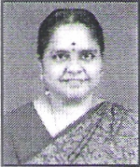
Kudos
Thiru. K.R. Narayanan - AM11 5" wrote "Excerpts from a programme "Nalamai Vazha" in FM Gold Radio.
As is your diet, so is your diabetes / Keep pace slow, to avoid pace maker/ Go Slow, the Heaven is not going to fall /Tension needs urgent attention, to avoid Hypertension / Respect your body and body will earn respect for you. +
Mail Box
1\
Exnora to plant 1000 sapling this year Age can never pose a barrier against the will to save the environment. This was clearly demonstrated, as 101- year- old Padmanabha Chetty and one-year-old C Sivagami planted tree saplings, in the Andhra Social and Cultural Club as a part of the Exnora International TREE initiative. +
Shorthand goes hi-tech : Data entry has never been this easy. Now all one has to do is, type in shorthand symbols on a specially - enabled computer keyboard and then tap a specially - enabled computer keyboard and then tap a specified key to change them into written English. This simple and swift data entry method has been made possibie by 'Newrite,' a software. Newrite, involving computer connected shorthand was released on(19-02-06) at the 70th Founding day celebrations of the Stenographers' Guild inChennai. +
MOMENT OF GLORY
C.B.K. Menon
I had a strange dream Last night
That I was answering a knock at the door And before me stood a giant of a man Such a man I had never seen before. I called him in, but all he did
was gust laugh and then said
"No body calls me in, Son,
They dread me, because
I am the 'Lord of death'
'Oh Lord of death' I said
Please Sir, come in.
I am ready to be taken
But, Can't you make this moment A little pleasant
All I heard was a roar of further laugh which made me wake in a stoic shudder But friends, He is sure to come
And that moment to me
Is a'Moment of Glory'.
Courtesy: Seniors' View +
Musings
Mr. S.V. lyer, President, Senior Citizens Association, Pondicherry, JS -192ofSCB, celebrated the marriage of his youngest son, Krishnan with Asha on 01-04-2006 at Pondicherry.
Our best wishes to the newly wedded couple. +
The Kilpauk Residents Welfare Association (KRWA) conducted a free eye checkup and screening camp on 26-03-2006 at S.C. S. Kothari Academy for women. Kilpauk, Chennai - 10. A 3 member committee of KRWA visited the following three orphonages to whom your support and contribution are welcome --
- Balavihar, Halls Road, Kilpauk Ph - 2644 7933
- Mercy Home, Halls Road, Kilpauk Ph : 2644 2820
- Children's Home
804, PH Road, next to EGA theatre, Kilpauk. Ph : 2641 1890
Let us join to 'Care & Share'
TANSECA is organisin^{g} tour to Goa in April and 2 trips to Singapore and Malaysia in April and May 2006. Please Contact :
Ph - 044-2621 3850, 2621 3908. +
Senior Citizens Club, Vile Parle (East), Mumbai in their regular monthly meeting heldon26-03-06 conducted Classical Sangeet, by PT Padmadar Laxman Thatte. +
Indian Liberal Group (ILG) convened a Special National Convention at Mumbai on March 11 and 12, 2006 +
World Kidney Day was observed on March 9, 2006. by the International Society of Nephrology (ISN) and the International Society of Kidney Federation (ISKF). Early detection and prevention is thethemeforthe inaugural World Kidney Day. It has been reported that Chronic Kidney diseases and vascular diseases will kill 36 million people by the year 2015.
Dr. M.S. Amaresan, a renowned Nephrologist, LM-21 of SCB, honoured Kidney transplant surviWors and donors at his Best Hospital to commomorate this day. +
in recognition of her contribution to Geriatric Nursing, when Probus Club of Chennai, celebrated World Womens day on 09-03-06. There was a dance feature entitled 'Navamanimalal" based on songs of Bharathlar and conceived by Mrs. Kalpakann Srinivasamurtl and 'Ragamalika' by
Probus members / spouses. +
Srivarsha, Grand daughter of Dr. V. Balambal, EC member of SCB (LM-12), has won National level oratorical competition held at Jaipur, organised by British Scholars Association and TATA industries, and got selected for Global Young leaders conference at New York. +
Abhiram Chakraborty, a final year Electronics and Communication Engineering student of Sri Sal Ram Engineering College, has come up with the idea of a smart cap which would serve as a tele- warning system for epilepsy patients using GPS and Embedded Systems. "The device, can be worn by those suffering from epilepsy. It would help to detect the seizure early and would convey information about the location of the patient, instantly to his doctor or relatives. It would also prevent them from getting injured during the seizure." His paper on the concept has been selected for publication by the Ukranian Journal of Telemedicine and Medical Telematics. +
Thiru Marudhachalam, President of Youth Welfare Council and Convenor of People Front at Irugur in Coimbatore Dist of TN is among the 27 youths of the country who were awarded "National Youth Award" at Patna on 13-02-2006 for his outstanding services 'in successfully organising various community welfare activities at Irugur. +
Tmt. Kausallya
Sarathy, active member of SCB (LM-19) was presented with Probus Award of Excellence by the Probus Club of Chennai,
I,1
April 2006 LinkAge A monthly journal of Senior Citizens Bureau

Published by Eng.Capt.M. Singaraja on behalf of Senior Citizens Bureau, (R.0) New No. 90, Rama Naicken Street, Nungarnbakkam, Chennai - 600 034. Z: 2823 1388.
Printed by SriKalaivani at Sri Maruthy Laser Printers, 173, Peters Road, Royapettah, Chennai - 600 014. (C⁻) :2852 4256
Editor : Capt.M. Singaraja, C.Eng., Asst. Editor.- M. Mahadevan, M.A., M.Ed.
I/
ID-AM-347 Phone: 04⁻4-22344b/4 THANYAKUNIAR.S
1/61-23, 2ND ST., RAVI COLONY,
ST.-THOMAV MOUNT
CHENNAI
600016-TANJILINIADU
TO
If undelivered please return to : Senior Citizen Bureau (A.0.) No. B-30, 1st Floor, Anna Nagar(East),
Chennai - 600 102. Ph : 2628 2018

RNI Reg n. No.TN ENG/2004/13996
Postal Regn. RNP No. TN/C H(C)/37/04-06, valid upto 31-12- 06. Licenced to post without prepayment vide No. WPP / 41/ 05-07. Posted at Patrika Channel, Egmore RMS on 08th of every month.
Elders Helpline at 'TANSECA - Ph. No. is 044-26213850.
A new, toll-free 'Call Chen nai' service *.
Call 24444444 to get all important numbers.
Visit for latest updates on Elder Welfare sites - <www.geriatri.org>, <www.wor1dcongress.com>, <www.oecd.org>,
<www.poetryarchive.orp : A fantastic poetry archive site.
<www.free-ed1.neVfree-cd> : A free online course for careers and critical academic disciplines. <www.word2word.com/coursead.html> : A site for learning more than 100 languages
<www.mha.niicJn>: Suggestions invited for a new Police Act, by Ministry of Home Affairs, Govt. of India, New Delhi.4-
Tit Bits
- Minister of state for finance, Govt. of India has stated in the Parliment that constitution of Sixth Central Pay Commission is under active consideration and shall be set up at the earliest.
- Merger of 50% dearness relief with pension to central Govt. Pensioners / family pensioners with effect from 01-04-2004 has already been given effect.
- Govt. of Tamil Nadu has issued orders for the merger of 50% of DA with basic pay and pension with effect from 01-01-2006. Vide Go. MS. No. 105 dt 07-02-2006.
- Govt. of Tamil Nadu has also raised DA to 71% of basic pay/ pension. with effect from 01-01-2006. However consequent to merger of 50% of DA as stated above, the revised current DA is 21% on D.A. merged pay / pension. (Go. Ms. 107 dt. 07-02-2006.)
- The present level of Lumpsum Payment of Rupees one lakh as family security fund for Tamil Nadu Government Employees is enhanced to Rs. 1.50 lakhs. The existing monthly contribution by Govt. Employees is also enhanced from Rs.20/- to Rs. 30/- with effect from Feb. 2006. (Go Ms. No. 131 - Finance - Pension Dept. Dt. 21-2-2006) .4>
Help Line / Useful Websites
(GOD BLESS TO--U)
Your birthday Contribution for Sunshine Fund is most welcome
DM - Donor Member- LM - Life Member, AM - Annual Member
Days to Remember - April
01 - All Fools Day
05 - National Maritime Day
07 - World Health Day
08 - Safe Mother Hood Day
11 - National Safe Mother Day 18 - World Heritage Day
22 - Earth Day
23 - Book and Copy Right Day 30 - AntiChild Labour Day
YOUR BALLOT IS PRECIOUS.
IT IS YOUR DUTY TO MAKE USE OF IT
(W⁻ITHING YOU A CHEERFUL |  |  |  | AND PEACEFUL LONG LIFE.
S.No. | DOB | Memb.No. |  | Name
01 | 01.04.36 | AM | 313 | S. Sarweswara Rau
02 | 02.04.30 | AM | 324 | Mrs. Patricia Ireland
03 | 02.04.46 | AM | 157 | A.G. Manuel
04 | 06.04.22 | LM | 056 | K. Ramanathan
05 | 07.04.28 | AM | 186 | K.S. Jagadeesan
06 | 11,04.28 | DM | 014 | S.P. Ambrose
07 | 11.04.31 | AM | 427 | R.P. Winfred Bunyan
08 | 12.04.27 | LM | 008 | AN. Manavalarathnam
09 | 13.04.34 | AM | 304 | A.P. Somasundaram
10 | 14.04.52 | AM | 297 | A. Vidyadhar
11 | 14.04.33 | AM | 094 | V.M. NIthyanandan
12 | 14.04.29 | AM | 349 | S. Ramakrishnan
13 | 15-04.42 | LM | 019 | Kousalyasarathy
14 | 15.04.34 | AM | 190 | L. Kalyanasunclaram
15 | 15-04.41 | AM | 420 | N. Krishnamurty
16 | 16-04.33 | LM | 088 | P.V.R. Raja
17 | 17-04.45 | AM | 027 | C. Panneer Selvam
18 | 17.04.22 | AM | 123 | G. Sundara Rajan
19 | 19.04.39 | AM | 306 | V. Ramakrishnan
20 | 19.04.39 | LIVI | 160 | M. Mahadevan
21 | 23,04.33 | AM | 247 | S.T. Rangarajan
22 | 27.04.40 | AM | 355 | C.L. Mahadevan
23 | 27.04.14 | AM | 111 | C. Bala Sulararnanian
24 | 29.04.35 | AM | 115 | K.R. Narayanan
25 | 29.04.34 | AM | 136 | C.Siva Subramaniam
26 | 29.04.35 | AM | 032 | S.V. Vaidyanathan

I
.Birthdays lApril. ..'
Senior Citizens Bureau
0 April 2006 -*.- LinkAge A monthly journal of

